My apologies, but I missed some hardware for the LowSpec2.   
  
Specifically you'll need to get Qty 6 of an M4-0.7mm nuts. These are for the cover bolts and the thumb screw that holds the guide camera.   
  
Also don't forget to get Qty 2 of an M5-0.8mm nuts for the Focus threaded rod.   
  
Both can be purchased at Home Depot or Lowe's.   
  
Also if your going to do much of this stuff I would go to Harbor Freight and  buy a drill set that includes numbered, fractional and letter drill bits. These are not production drills but for plastics they will do.   
  
To install the thumb screw nut drill out the existing hole with a "N"  dull drill to a depth of about 1/8" Then tap the nut into place and glue. If you don't have an "N" drill use a 5/16" drill and glue. Also I filed the end of this thumb screw smooth so that it didn't scratch the nose of my guide camera.   
  
Note on drilling plastic: on the cutting edge of the drill bit break the sharp edge so that it doesn't grab and drill all of the way through. See the attached image (enlarge if necessary). The idea is to scrape the plastic away rather than cut it away. Keep this drill just for plastics

. 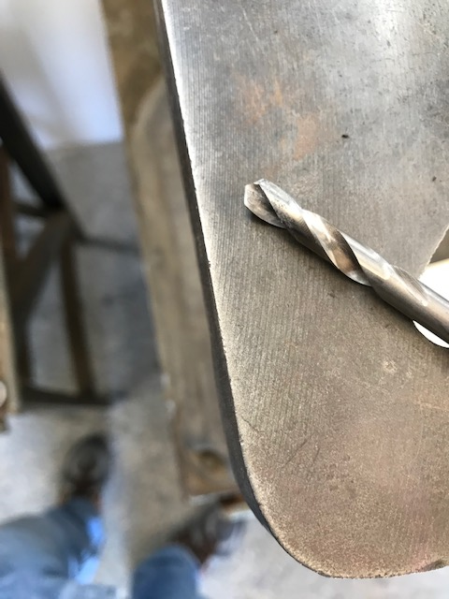  
  
I have been assembling the LowSpec2 with two different adhesives: To hold nuts in place I use Cyanoacrylate medium thick and use a spray Kicker. Hobby stores have this stuff. The Kicker accelerates the cure of the CA. The other adhesive is two part epoxy. Again check the hobby store. I used epoxy to secure the two rings on the telescope port and the camera port.   
  
In order to make the grating assembly rotate easily,  I had to file a few tight spots. Also if your going to make this assembly removable as in Tony's design you'll need to drill out the locations on the assembly base to accept the M3 screws. I used a 1/4" drill and went only deep enough to seat the nut flush. with the top surface. Again, dull the drill or you'll go right through (don't ask me how I know).   
  
With Tony's hatch on the lid I used two of the M3 x 10mm flat head screws. Drilling out the lid to tap the M3 screw (#39) and drilling the hatch cover with a #31 drill. No need to dull drill as these are both drilled through. You can also use the 1/4" dulled drill to countersink the hatch holes a little for the flat heads. It isn't necessary to tap the M3 holes in the lid as the screws self tap easily.   
  
Also when tapping the M4 holes I have found that the printed hole is a little small so I enlarged these using a #29 drill first.  
  
I just received the metal T2 extension rings and I think that using a 5mm one as the active mating section on both the camera and telescope ports is a good idea. That will preserve the plastic threads.   
  
  
Jerry